SIMATS ENGINEERING

ASSESSMENT TOOL 2: Logic Reasoning & Mapping Exercise

COURSE NAME: | ARTIFICIAL INTELLIGENCE  AND EXPERT SYSTEMS | COURSE CODE: | MLA01

COURSE OUTCOME COVERED
CO3: Implement propositional and first-order logic using resolution, unification, and inference techniques for knowledge representation and reasoning.(BTL 3) Assessment Tool Weightage: 15%

Total Marks: 100 Time: 60 Mins
No. of Questions: 5
Annexure A

Logic Reasoning & Mapping Exercise

Code of Conduct:

I SAHIL.J (192525200) (Name / Reg No) certify that this submission is my original work and that I have adhered to the guidelines specified for this assessment. I understand that any violation of academic integrity rules will result in disciplinary action.

Signature of the student: Sahil

Criterion | Weightag  e | Marks Obtained
1. Problem Analysis and Knowledge Identification | 15%
2. Logical Representation and Mapping | 20%
3. Predicates, Variables, Constants and Quantifiers | 15%
4. Logical Connectives and Formula Construction | 10%
5. Inference and Logical Reasoning | 15%
6. Unification and Substitution | 10%
7. Resolution and Proof Construction | 10%
8. Mapping Diagram / Clarity and Presentation | 5%
Total | 100%

Q1. Smart Healthcare Diagnosis – Knowledge Identification
LOGIC SNAPSHOT Given symptoms → Flu → Viral Infection → Medical Attention.
Scenario focus: Ravi has fever, cough, and body pain. Fever plus cough implies flu; flu plus body pain implies viral infection; viral infection implies medical attention. These are the exact reasoning relationships specified in the assessment. fileciteturn0file0L37-L50

(i) Facts, Entities, Predicates, Variables and Constants
Component | Identification | Meaning
Entity | Patient / Ravi | Individual under diagnosis
Constant | Ravi | Names the specific patient
Predicates | Fever(x), Cough(x), BodyPain(x) | Symptoms
Predicates | Flu(x), ViralInfection(x), MedicalAttention(x) | Derived states/actions
Variables | x | Represents any patient
Facts | Fever(Ravi), Cough(Ravi), BodyPain(Ravi) | Given observations
Rules | Fever∧Cough→Flu; Flu∧BodyPain→Viral; Viral→Attention | Knowledge rules
Knowledge Base
Fever(Ravi) ∧ Cough(Ravi) ∧ BodyPain(Ravi)
Fever(x) ∧ Cough(x) → Flu(x)
Flu(x) ∧ BodyPain(x) → ViralInfection(x)
ViralInfection(x) → MedicalAttention(x)
Key observation
The facts alone do not explicitly state viral infection; it is derived by chaining the two disease rules. This step-by-step inference directly targets the rubric requirement for accurate reasoning.

Q1. Smart Healthcare – Propositional Logic & FOL

(ii) Propositional Logic
Let F = Ravi has fever, C = Ravi has cough, B = Ravi has body pain, L = Ravi has flu, V = Ravi has viral infection, and M = Ravi requires medical attention.
F ∧ C → L
L ∧ B → V
V → M
F, C, B (given facts)

(iii) First-Order Logic with Quantifiers
∀x [(Fever(x) ∧ Cough(x)) → Flu(x)]
∀x [(Flu(x) ∧ BodyPain(x)) → ViralInfection(x)]
∀x [ViralInfection(x) → MedicalAttention(x)]
Given facts: Fever(Ravi), Cough(Ravi), BodyPain(Ravi). Universal quantification makes each rule applicable to every patient

x.
(iv) Unification
Unification makes two predicate expressions identical by finding a substitution for variables.
Fever(x) and Fever(Ravi)
MGU = { x / Ravi }
Flu(y) and Flu(Ravi) ⇒ MGU = { y / Ravi }
Substitution Result
After applying {x/Ravi}, Fever(x) becomes Fever(Ravi), and the rule Fever(x) ∧ Cough(x) → Flu(x) can be instantiated for Ravi.
Rubric link
This section demonstrates predicates, variables, constants, universal quantifiers, logical connectives, and a Most General Unifier (MGU), matching the supplied 15% + 10% criteria for these skills.

Q1. Smart Healthcare – Resolution & Complete Inference
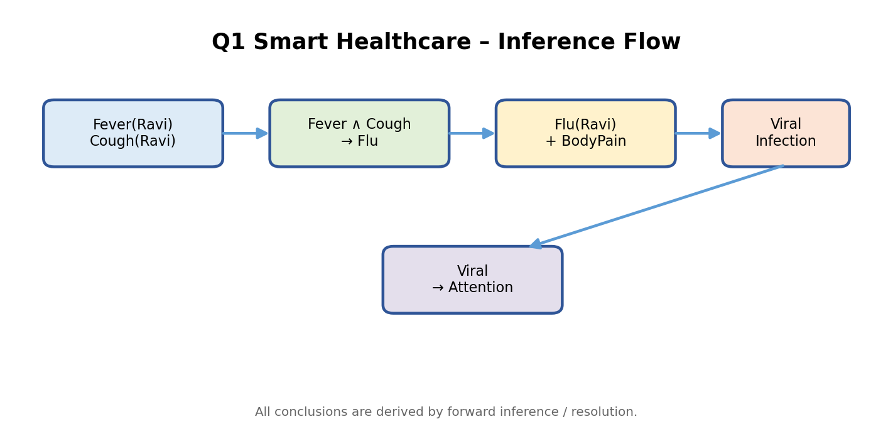

(v) Resolution Proof for ViralInfection(Ravi)
Convert the relevant rules to clauses:
C1: ¬Fever(x) ∨ ¬Cough(x) ∨ Flu(x)
C2: ¬Flu(x) ∨ ¬BodyPain(x) ∨ ViralInfection(x)
C3: Fever(Ravi)
C4: Cough(Ravi)
C5: BodyPain(Ravi)
To prove ViralInfection(Ravi), add the negated query C6: ¬ViralInfection(Ravi).
- Resolve C2 with C6 using x = Ravi → ¬Flu(Ravi) ∨ ¬BodyPain(Ravi).
- Resolve with C5 → ¬Flu(Ravi).
- Resolve C1 with ¬Flu(Ravi) and C3, C4 → contradiction (empty clause).
Therefore the negated query is inconsistent with the knowledge base.
Final conclusion
Ravi HAS a viral infection according to the supplied rule set. Since ViralInfection(Ravi) is derived, the final rule also gives MedicalAttention(Ravi).

Q2. Student Academic Advising – Knowledge & Propositional
Mapping
DECISION SNAPSHOT Low attendance + two failed courses → both counseling types → Academic Support.
Scenario: Priya has attendance below 75% and has failed two courses. Low attendance requires attendance counseling; failing
two or more courses requires academic counseling; both counseling types imply academic support. fileciteturn0file0L51-L65

(i) Knowledge Components
- Entity / constant: Priya.
- Predicates: LowAttendance(x), FailedTwoOrMore(x), AttendanceCounseling(x), AcademicCounseling(x), AcademicSupport(x).
- Facts: LowAttendance(Priya), FailedTwoOrMore(Priya).
- Rules: LowAttendance → AttendanceCounseling; FailedTwoOrMore → AcademicCounseling; both counseling types → AcademicSupport.

(ii) Propositional Logic
A = Priya has low attendance
F = Priya failed two or more courses
AC = Priya needs attendance counseling
CC = Priya needs academic counseling
S = Priya needs academic support
A → AC
F → CC
AC ∧ CC → S
A ∧ F (facts)
Mapping Diagram
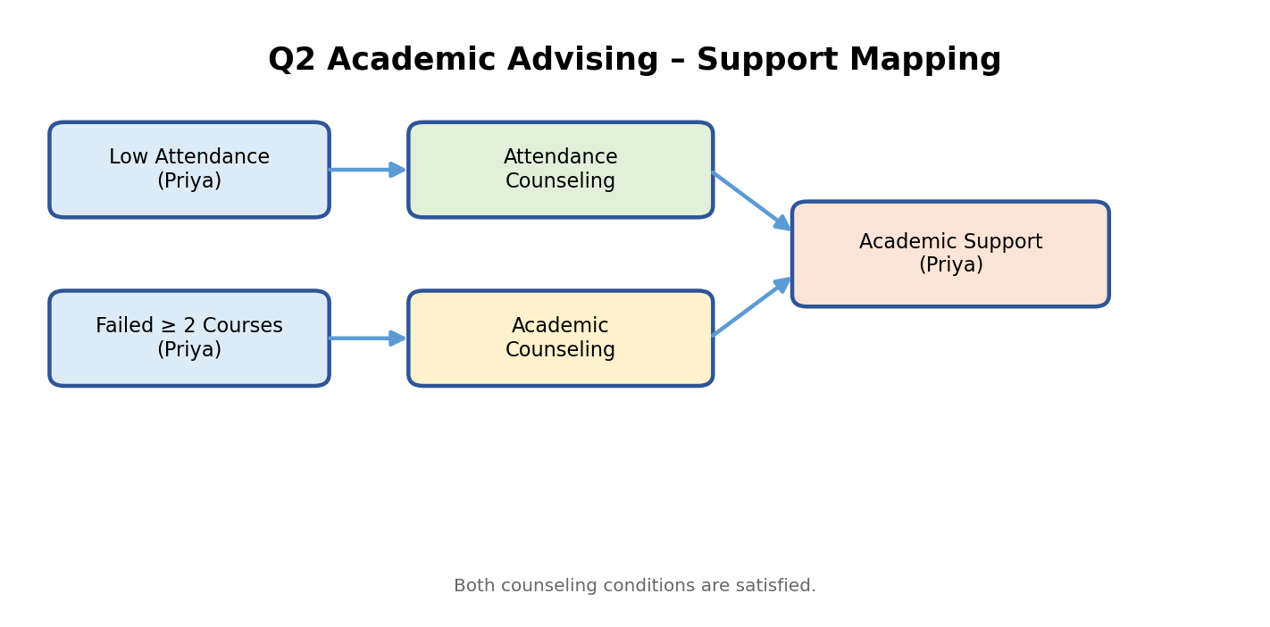

Q2. Student Academic Advising – FOL, Unification & Resolution
(iii) FOL Representation
∀x [LowAttendance(x) → AttendanceCounseling(x)]
∀x [FailedTwoOrMore(x) → AcademicCounseling(x)]
∀x [(AttendanceCounseling(x) ∧ AcademicCounseling(x)) → AcademicSupport(x)]
LowAttendance(Priya) ∧ FailedTwoOrMore(Priya)

(iv) Unification & Substitution
LowAttendance(x) ↔ LowAttendance(Priya) ⇒ {x/Priya}
FailedTwoOrMore(x) ↔ FailedTwoOrMore(Priya) ⇒ {x/Priya}
The same substitution x = Priya instantiates the universal rules for the specific student.

(v) Resolution Proof
¬LowAttendance(x) ∨ AttendanceCounseling(x)
¬FailedTwoOrMore(x) ∨ AcademicCounseling(x)
¬AttendanceCounseling(x) ∨ ¬AcademicCounseling(x) ∨ AcademicSupport(x)
Using the two facts, derive AttendanceCounseling(Priya) and AcademicCounseling(Priya). Combining them with the final rule derives AcademicSupport(Priya).

(vi) Final Inference
Conclusion
Priya requires academic support because both antecedent conditions are satisfied: low attendance produces attendance counseling, and two failed courses produce academic counseling. Their conjunction produces academic support.

Q3. Intelligent Loan Approval – Knowledge Identification
APPROVAL SNAPSHOT Stable employment + income → preliminary approval → low-risk → loan approval.
Scenario: Arun has stable employment, sufficient income, a high credit score, and good repayment history. Stable employment plus sufficient income gives preliminary approval; high credit score plus preliminary approval gives low-risk; low-risk plus good repayment history gives loan approval. fileciteturn0file0L66-L78

(i) Entities, Facts, Predicates & Rules
Type | Representation | Role
Entity / Constant | Arun | Specific customer
Facts | StableEmployment(Arun) | Employment status
Facts | SufficientIncome(Arun) | Income condition
Facts | HighCreditScore(Arun) | Credit condition
Facts | GoodRepaymentHistory(Arun) | Repayment condition
Derived | PreliminaryApproval(x) | First-stage approval
Derived | LowRisk(x) | Risk classification
Goal | LoanApproved(Arun) | Final recommendation
Rules
StableEmployment(x) ∧ SufficientIncome(x) → PreliminaryApproval(x)
HighCreditScore(x) ∧ PreliminaryApproval(x) → LowRisk(x)
LowRisk(x) ∧ GoodRepaymentHistory(x) → LoanApproved(x)

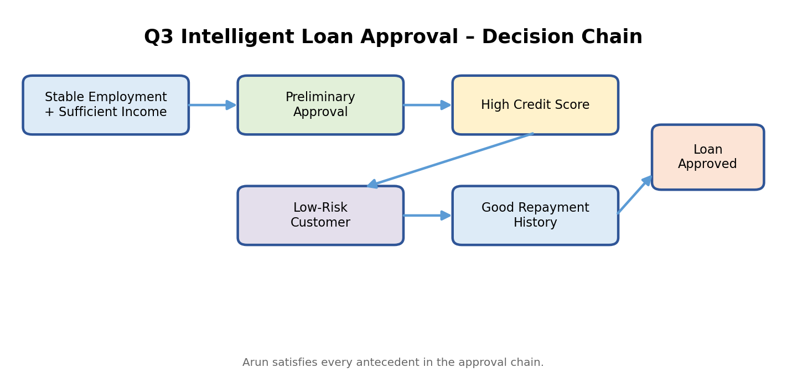

Q3. Intelligent Loan Approval – Logic Mapping

(ii) Propositional Logic
E = Arun has stable employment
I = Arun has sufficient income
C = Arun has a high credit score
R = Arun has good repayment history
P = Arun qualifies for preliminary approval
L = Arun is low-risk
A = Arun is recommended for loan approval
E ∧ I → P
C ∧ P → L
L ∧ R → A
E ∧ I ∧ C ∧ R (given facts)

(iii) FOL Rules
∀x [(StableEmployment(x) ∧ SufficientIncome(x)) → PreliminaryApproval(x)]
∀x [(HighCreditScore(x) ∧ PreliminaryApproval(x)) → LowRisk(x)]
∀x [(LowRisk(x) ∧ GoodRepaymentHistory(x)) → LoanApproved(x)]

(iv) Unification & Substitution
StableEmployment(x) with StableEmployment(Arun) ⇒ {x/Arun}
PreliminaryApproval(x) with PreliminaryApproval(Arun) ⇒ {x/Arun}
LowRisk(x) with LowRisk(Arun) ⇒ {x/Arun}
These substitutions allow each general rule to be applied specifically to Arun.
Decision chain
Facts → Preliminary Approval → Low-Risk Classification → Loan Approval recommendation.

Q3. Intelligent Loan Approval – Resolution & Final Inference
(v) Resolution to Prove LoanApproved(Arun)
Relevant clauses:
C1: ¬StableEmployment(x) ∨ ¬SufficientIncome(x) ∨ PreliminaryApproval(x)
C2: ¬HighCreditScore(x) ∨ ¬PreliminaryApproval(x) ∨ LowRisk(x)
C3: ¬LowRisk(x) ∨ ¬GoodRepaymentHistory(x) ∨ LoanApproved(x)
C4: StableEmployment(Arun)
C5: SufficientIncome(Arun)
C6: HighCreditScore(Arun)
C7: GoodRepaymentHistory(Arun)
Negate the goal: C8 = ¬LoanApproved(Arun).
- Resolve C1 with C4 and C5 → PreliminaryApproval(Arun).
- Resolve C2 with C6 and PreliminaryApproval(Arun) → LowRisk(Arun).
- Resolve C3 with LowRisk(Arun) and C7 → LoanApproved(Arun).
- LoanApproved(Arun) conflicts with C8, producing the empty clause.
(vi) Final Inference
Conclusion
LoanApproved(Arun) is proved by the supplied rule chain. Therefore the knowledge base supports a preliminary loan approval recommendation for Arun.

Q4. Vehicle Fault Diagnosis – Facts, Rules & Logic
DIAGNOSIS SNAPSHOT Does not start + dim headlights → battery problem → inspection → service.
Scenario: Car101 does not start and its headlights are dim. Those two conditions imply a battery problem; a battery problem requires inspection; inspection results in the vehicle being marked for service. fileciteturn0file0L84-L99

(i) Facts & Rules
- Fact 1: DoesNotStart(Car101).
- Fact 2: DimHeadlights(Car101).
- Rule 1: DoesNotStart(x) ∧ DimHeadlights(x) → BatteryProblem(x).
- Rule 2: BatteryProblem(x) → BatteryInspection(x).
- Rule 3: BatteryInspection(x) → MarkedForService(x).

(ii) Propositional Logic
D = Car101 does not start
H = Car101 has dim headlights
B = Car101 has a battery problem
I = Car101 requires battery inspection
S = Car101 is marked for service
D ∧ H → B
B → I
I → S
D ∧ H (facts)
(iii) FOL
∀x [(DoesNotStart(x) ∧ DimHeadlights(x)) → BatteryProblem(x)]
∀x [BatteryProblem(x) → BatteryInspection(x)]
∀x [BatteryInspection(x) → MarkedForService(x)]
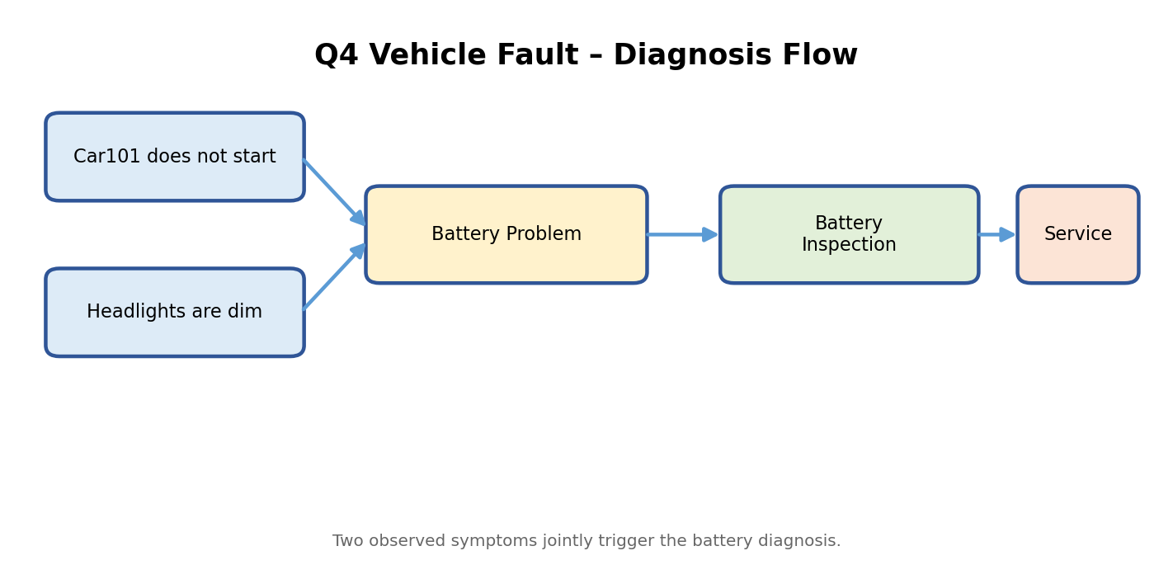
Q4. Vehicle Fault Diagnosis – Unification & Resolution
(iv) Unification
DoesNotStart(x) with DoesNotStart(Car101) ⇒ {x/Car101}
DimHeadlights(x) with DimHeadlights(Car101) ⇒ {x/Car101}
BatteryProblem(x) with BatteryProblem(Car101) ⇒ {x/Car101}
(v) Resolution for BatteryProblem(Car101)
C1: ¬DoesNotStart(x) ∨ ¬DimHeadlights(x) ∨ BatteryProblem(x)
C2: DoesNotStart(Car101)
C3: DimHeadlights(Car101)
C4: ¬BatteryProblem(Car101) (negated query)
- Resolve C1 with C2 → ¬DimHeadlights(Car101) ∨ BatteryProblem(Car101).
- Resolve with C3 → BatteryProblem(Car101).
- Resolve with C4 → empty clause.
(vi) Service Inference
BatteryProblem(Car101) → BatteryInspection(Car101)
BatteryInspection(Car101) → MarkedForService(Car101)
Final conclusion
Car101 has a battery problem and should be marked for service. The conclusion follows from the two observed symptoms and the two downstream rules.

Q5. Cybersecurity Threat Detection – Knowledge Identification
Scenario: User101 has five failed login attempts and logged in from an unusual location. Multiple failed logins imply a possible brute-force attack; brute-force plus unusual location implies suspicious activity; suspicious activity plus unauthorized access to confidential files implies a possible security breach. fileciteturn0file0L100-L116
(i) Facts, Entity, Predicates & Rules
Type | Representation | Meaning
Entity / Constant | User101 | Specific user
Fact | FiveFailedLogins(User101) | Five failed attempts
Fact | UnusualLocation(User101) | Login from unusual location
Possible derived | BruteForceAttack(User101) | Threat indicator
Derived | SuspiciousActivity(User101) | Combined risk signal
Possible final | SecurityBreach(User101) | Requires unauthorized file access too
Rules
FiveFailedLogins(x) → BruteForceAttack(x)
BruteForceAttack(x) ∧ UnusualLocation(x) → SuspiciousActivity(x)
SuspiciousActivity(x) ∧ UnauthorizedFileAccess(x) → SecurityBreach(x)
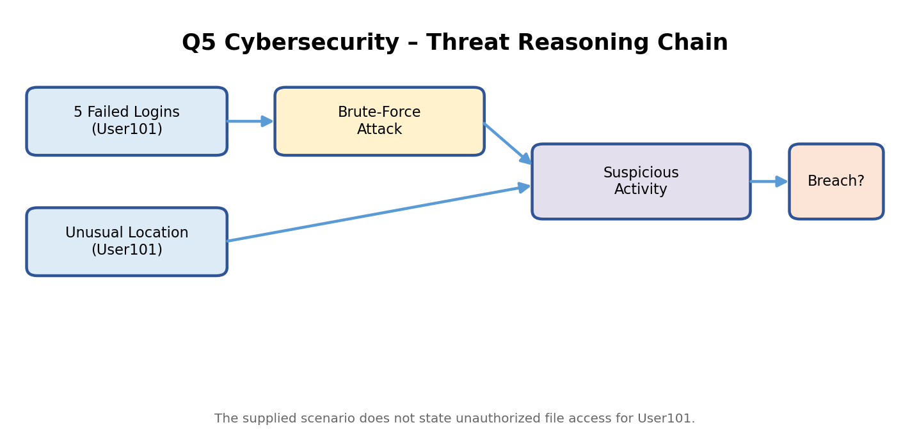

Q5. Cybersecurity – Propositional Logic, FOL & Unification
(ii) Propositional Logic
F = User101 has five failed login attempts
U = User101 logged in from an unusual location
B = User101 may be involved in brute-force attack
S = User101 shows suspicious activity
A = User101 has unauthorized access to confidential files
R = User101 may be involved in a security breach
F → B
B ∧ U → S
S ∧ A → R
F ∧ U (given facts)
(iii) FOL
∀x [FiveFailedLogins(x) → BruteForceAttack(x)]
∀x [(BruteForceAttack(x) ∧ UnusualLocation(x)) → SuspiciousActivity(x)]
∀x [(SuspiciousActivity(x) ∧ UnauthorizedFileAccess(x)) → SecurityBreach(x)]
(iv) Unification & Substitution
FiveFailedLogins(x) with FiveFailedLogins(User101) ⇒ {x/User101}
BruteForceAttack(x) with BruteForceAttack(User101) ⇒ {x/User101}
SuspiciousActivity(x) with SuspiciousActivity(User101) ⇒ {x/User101}
Important logical condition
The assessment scenario does NOT explicitly give UnauthorizedFileAccess(User101). Therefore the final security-breach predicate cannot be conclusively derived from the supplied facts alone.

Q5. Cybersecurity – Resolution, Complete Reasoning & Final Inference

(v) Resolution Analysis
C1: ¬FiveFailedLogins(x) ∨ BruteForceAttack(x)
C2: ¬BruteForceAttack(x) ∨ ¬UnusualLocation(x) ∨ SuspiciousActivity(x)
C3: ¬SuspiciousActivity(x) ∨ ¬UnauthorizedFileAccess(x) ∨ SecurityBreach(x)
C4: FiveFailedLogins(User101)
C5: UnusualLocation(User101)
- C1 + C4 ⇒ BruteForceAttack(User101).
- C2 + BruteForceAttack(User101) + C5 ⇒ SuspiciousActivity(User101).
To prove SecurityBreach(User101), C3 still requires UnauthorizedFileAccess(User101). That fact is absent from the given scenario.

(vi) Complete Reasoning Chain
5 Failed Logins → Brute-Force Attack → Suspicious Activity
Suspicious Activity + Unauthorized File Access → Security Breach
Final conclusion
User101 IS supported as showing suspicious activity, but a possible security breach is NOT provable from the supplied facts because unauthorized access to confidential files is not provided. A logically correct resolution proof must stop at SuspiciousActivity(User101).

EVALUATION RUBRICS:

Criterion | Weightage (%) | Excellent | Good | Average | Poor
Problem Understanding & Knowledge Identification | 15% | 13–15% –  Clearly  identifies entities, facts, relationships, assumptions, and reasoning requirements from the given scenario. | 10–12% –  Identifies most relevant  knowledge with minor omissions. | 7–9% –  Identifies basic knowledge but misses several important elements. | 0–6% – Poor or incorrect identification of the given  knowledge.
Logical Representation & Mapping | 20% | 17–20% –  Accurately maps  real-world  statements into appropriate propositional and first-order logic representations. | 13–16% –  Provides mostly correct logical  mappings with minor errors. | 9–12% –  Provides partial mappings with several logical errors. | 0–8% – Logical mapping is largely incorrect or missing.
Predicates, Variables,  Constants & Quantifiers | 15% | 13–15% –  Correctly  identifies and applies predicates, variables, constants, universal and existential quantifiers. | 10–12% –  Uses the concepts correctly with minor errors. | 7–9% –  Demonstrates partial understanding with some incorrect usage. | 0–6% – Concepts are incorrectly applied or missing.
Logical  Connectives & Formula Construction | 10% | 9–10% –  Correctly  applies AND, OR, NOT,  implication, and  equivalence to | 7–8% –  Mostly correct use of  connectives with minor errors. | 5–6% – Basic use of  connectives but several errors occur. | 0–4% – Incorrect or incomplete formula construction.

 |  | construct valid logical formulas.
Inference & Logical Reasoning | 15% | 13–15% –  Performs accurate  step-by-step reasoning and derives valid conclusions from the given knowledge. | 10–12% –  Reasoning is mostly correct with minor gaps. | 7–9% –  Provides partial reasoning with some incorrect conclusions. | 0–6% –  Reasoning is incorrect, unsupported, or missing.
Unification & Substitution | 10% | 9–10% –  Correctly identifies  substitutions and Most General Unifier (MGU) and  applies them accurately. | 7–8% –  Correctly performs most unification  steps with minor errors. | 5–6% –  Demonstrates basic understanding  but has several errors. | 0–4% – Unable to perform unification correctly.
Resolution / Proof Construction | 10% | 9–10% –  Correctly applies  resolution and presents a clear, logically valid proof of the query. | 7–8% –  Resolution is mostly correct with minor errors. | 5–6% – Shows partial understanding but proof contains gaps. | 0–4% –  Resolution is incorrect or not demonstrated.
Clarity, Mapping Diagram & Presentation | 5% | 5% – Provides a clear,  well-organized mapping/logic diagram with accurate notation and excellent presentation. | 4% –  Presentation is clear with minor formatting or diagram issues. | 3% – Basic presentation with limited clarity. | 0–2% – Poorly organized, unclear, or incomplete presentation.

